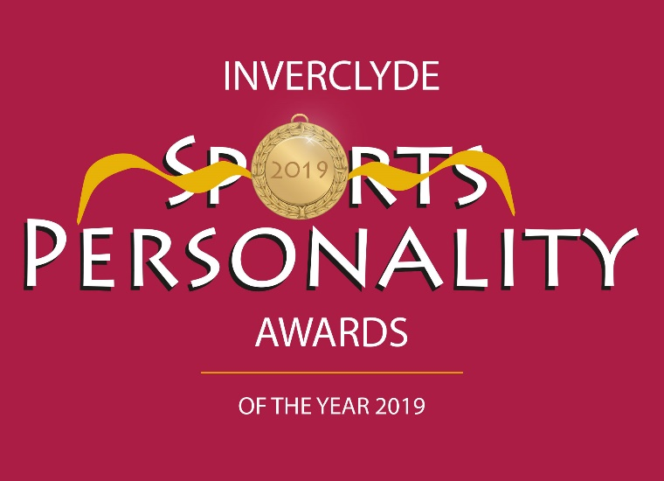

GREENOCK TOWN HALL – FRIDAY 27th MARCH 2020

NOMINATION FORM
Please complete and submit this form online with a head and shoulders and also an action picture of the nominee or download it and complete it by hand and send it with the pictures to Chris Jewell, Inverclyde Sports Personality Awards, 43A Esplanade, Greenock PA16 7RY to arrive by 3rd February 2020. It can also be downloaded, completed and scanned in and emailed to ispagreenock@gmail.com.

In respect of the Coach of the Year and the Junior and Adult Volunteer Awards there is a separate Nomination form which is found on our website. Please complete that form for these categories ONLY and submit it or post it with photographs.

NEW An important element of the individual Sports Personality Awards (Senior, Junior and Disabled) is what the nominee has done over the year to promote his/her sport.

~~~~~~~~~~~~~~~~~~~~~~~~~~~~~~~~~~

5) Judging of nominations in all categories will be carried out by a specially selected panel. All decisions of the selection panel will be final.

The closing date for nominations for the 2019 awards is 3rd February 2020. Nominations received after this date and time cannot be considered.
3) ‘Junior’ usually means under 18 years of age; however it is appreciated that in some sports a person may be allowed to compete as a junior at an older age. This will not exclude such nominees from being considered as juniors.
2) All awards are judged on the basis of a sportsperson’s or team’s/club’s
achievements in 2019; please do not include details of achievements in previous years.
1) Candidates for awards must be resident in Inverclyde and / or competing for an Inverclyde based club.
4) A person may be nominated for an individual award and be a member of a team/club which has been nominated for the team/club award.
NOMINEE FOR AN AWARD

Name

Age as at 31 Dec 2019

Address

Post Code

Daytime Tel. No.

Mobile Tel No.

Email address

Sport

Club

Governing Body

PERSON MAKING THE NOMINATION

Name

Address

Post Code

Email address

Daytime Tel No.

Mobile Tel No.

Date submitted

CATEGORY OF AWARD (tick all being nominated for)

Senior Sports Personality of the Year
Junior Sports Personality of the Year
Disabled Sports Personality of the Year
Team of the Year
School Team of the Year
Club of the Year

For Coach of the Year, Young Volunteer of the Year and Adult Volunteer of the Year please complete the sportscotland nomination form available on the website www.inverclydesportspersonality.com
AWARDS AND ACHIEVEMENTS ATTAINED DURING 2019

At local level

At national level

At international level

For the Senior, Junior and Disabled Sports Personality categories; What has the nominee done to benefit and promote his/her sport in the local community and beyond in 2019?

Name of Nominator
Email address of nominator
Contact Tel no. of nominator
Date

