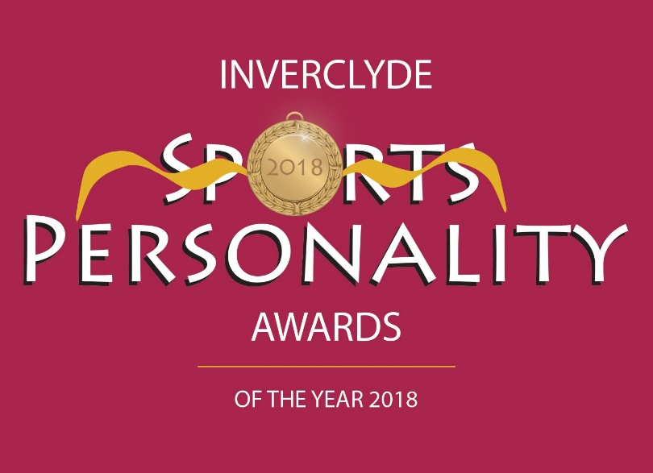

**GREENOCK TOWN HALL – FRIDAY 8TH MARCH 2019**

**NOMINATION FORM**

5) Judging of nominations in all categories will be carried out by a specially selected panel. All decisions of the selection panel will be final.

The closing date for nominations for the 2018 awards is 14 January 2019. Nominations received after this date and time cannot be considered.

Please complete and submit this form online with a head and shoulders and also an action picture of the nominee or download it and complete it by hand and send it with the pictures to Chris Jewell, Inverclyde Sports Personality Awards, 43A Esplanade, Greenock PA16 7RY to arrive by Monday 14th January 2019.

In respect of the Coach of the Year and the Junior and Adult Volunteer Awards there is a separate Nomination form which is found on our website. Please complete that form for these categories ONLY and submit it or post it with photographs.

***NEW*** An important element of the individual Sports Personality Awards (Senior, Junior and Disabled) is what the nominee has done over the year to promote his/her sport.

~~~~~~~~~~~~~~~~~~~~~~~~~~~~~~~~~~

3) ‘Junior’ usually means under 18 years of age; however it is appreciated that in some sports a person may be allowed to compete as a junior at an older age. This will not exclude such nominees from being considered as juniors.

2) All awards are judged on the basis of a sports person or team’s/club’s

achievements in 2018; please do not include details of achievements in previous years.

1) Candidates for awards must be resident in Inverclyde and / or competing for an Inverclyde based club.

4) A person may be nominated for an individual award and be a member of a team/club which has been nominated for the team/club award.

**NOMINEE FOR AN AWARD**

**Name**

**Age as at 31 Dec 2018**

**Address**

**Post Code**

**Daytime Tel. No.**

**Mobile Tel No.**

**Email address**

**Sport**

**Club**

**Governing Body**

**PERSON MAKING THE NOMINATION**

**Name**

**Address**

**Post Code**

**Email address**

**Daytime Tel No.**

**Mobile Tel No.**

**Date submitted**

**CATEGORY OF AWARD (tick all being nominated for)**

Senior Sports Personality of the Year

Junior Sports Personality of the Year

Disabled Sports Personality of the Year

Team of the Year

School Team of the Year

Club of the Year

For Coach of the Year, Young Volunteer of the Year and Adult Volunteer of the Year please complete the **sports**cotland nomination form available on the website [www.inverclydesportspersonality.com](http://www.inverclydesportspersonality.com)

**AWARDS AND ACHIEVEMENTS ATTAINED DURING 2018**

***At local level***

***At national level***

***At international level***

***For the Senior, Junior and Disabled Sports Personality categories; What has the nominee done to benefit and promote his/her sport in the local community and beyond in 2018?***

**Name of Nominator**

**Email address of nominator**

**Contact Tel no. of nominator**

**Date**